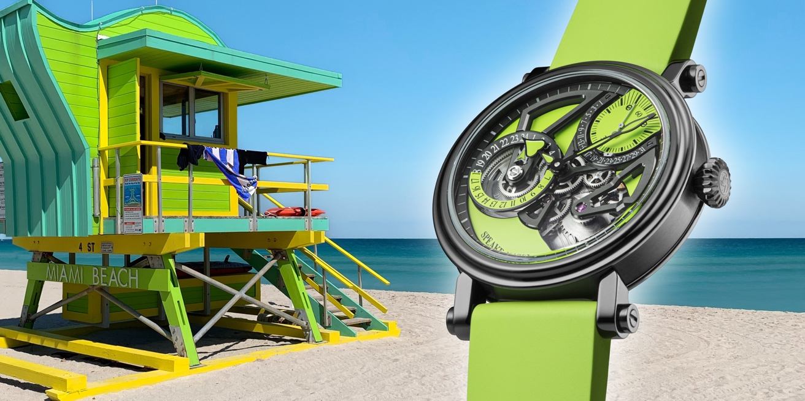

INSPIRATION

The new Dual Time Lime ‘Summer Edition’ invites you to escape, enjoy the summer with tropical fruits and cocktails under the sun and travel in a convertible super car wearing your new stunning Dual Time Lime!
The movement and dial structure of this new limited edition are true expressions of modern architecture, in this case, Speake-Marin uses elements of the ‘black architecture’ movement.
Being the ideal travel companion, the Dual Time Lime is a fearless and daring combination of contrasting colours and haute horlogerie, the perfect timepiece for globetrotters and global citizens.

MOVEMENT

Member of the SMA (Speake-Marin Atelier) family of in-house movements, the caliber SMA02 has been fully developed and assembled at Le Cercle des Horlogers. As part of the One &Two collection, the small second counter and the retrograde date indication at 1h30 makes it recognizable and unique. The local time is indicated by the central minute and hour hands and the home time is set on a 24-hour dial at 9 o’clock, which results in a well-balanced open worked movement design. Watchmaking at its finest by Speake-Marin.

ORIGIN

The Dual Time indication dates back to the fifties of last century when it was developed for the aviation industry to help pilots who were crossing several time zones in one trip and who needed to stay updated on their home time during the whole journey without having to make complicated calculations.

BLACK CASE

Most recent version of the famous Speake-Marin Piccadilly case in Titanium with black DLC treatment in which DLC describes the ‘diamond like’ irreversible carbon particle coating procedure which also makes the case extremely scratch resistant.

