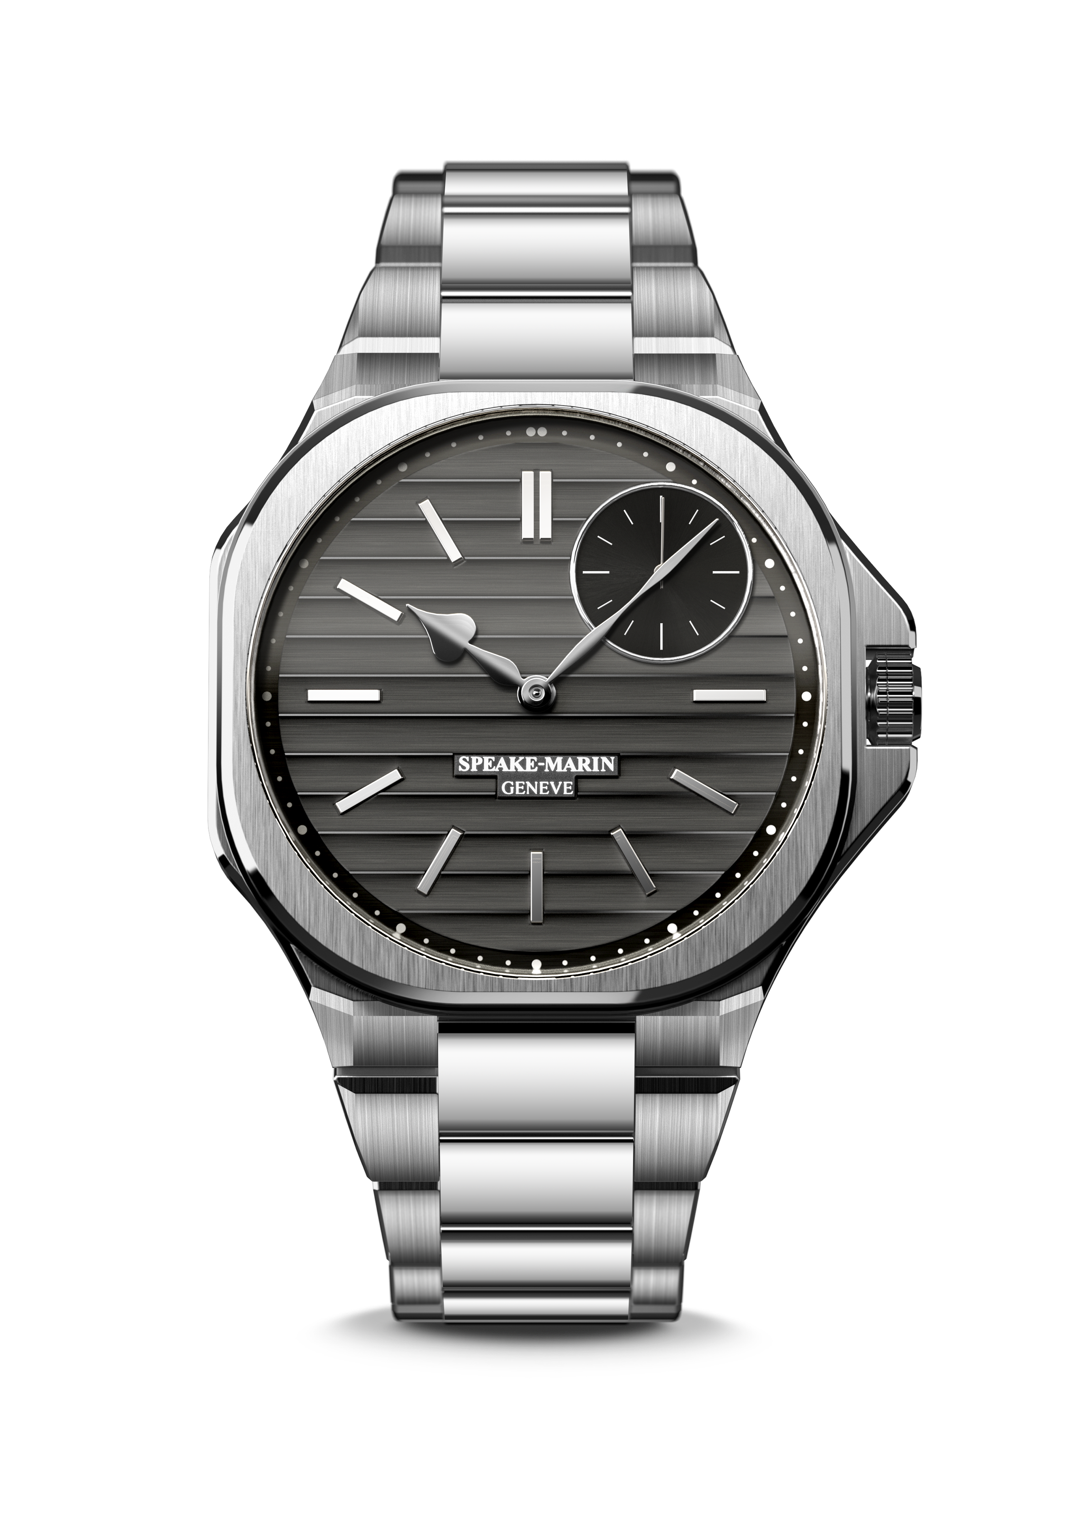

RIPPLES

Geneva, March 2022 – Speake-Marin opens a new creative chapter with the launch of a sport chic collection, the brand’s first ever bracelet watch in steel, called Ripples.
Ripples is inspired by modern architecture and designed for aesthetes of our times, with love for watchmaking details.

“RIPPLES” INSPIRATION

Ripples leads the way in this new sport chic collection, a reflection of our times, selected by the new aesthetes, the visionaries, the seekers of finesse, who overcome challenges in their fast-paced lives every day.
Discreet but complex, it adorns the wrist of those comfortable to be different and builds a bridge between tradition and the future.

The new case, called “La City” reflects the architecture of London's eponymous financial district, which combines business, heritage and design. A round square or a square in the round, Ripples offers an original shape and its "Big Ben" hands are a tribute to Speake-Marin's British roots.

Designed for the connoisseur who does not want to compromise on casual elegance, it is a piece that blends into everyday life and can be worn all week long, whether at work or under casual circumstances. Its exclusive contemporary design expresses the sharp taste and demonstrates a strong watchmaking knowledge of the wearer.

Its pure and precise shapes are reminiscent of the quest for perfect proportions by contemporary designers and architects. The new “Ripples” dial finishing developed by Speake-Marin is inspired by contemporary art and materials used for modern industrial design. Due to its innovative and complex dial, the watch looks different from every angle you look at it. As it reflects light in different ways, it changes colours and shapes.

The idea of the round in the square expression through its case, its wide Geneva stripes, hand bevelled bridges, inner angle, its "Ripples" dial and its light reflections push watchmaking beauty to an apparent simplicity.

It invites you to touch the essential, to experience comfort at all times and in all places, to combine fine watchmaking excellence and daily wear.

“RIPPLES” DEVELOPMENT

RIPPLES is part of a new chapter in the brand’s watchmaking tradition with the new inhouse movement SMA03-T coming out of the Swiss Research & Development department of Le Cercle Des Horlogers, a high end watch atelier which is owned by Speake-Marin President and CEO Christelle Rosnoblet. Its confident modernity is a step into the future for our collections with the new Sport Chic collection.

The small second at 1:30 is a unique Speake-Marin signature for its in-house movement’s. This reflects the brand’s know-how which pushes back the constraints of modern watchmaking. The SMA03-T is a 4 Hz automatic winding movement, its integrated micro-rotor is decorated with a sun-brushed finishing. The back of the case in sapphire crystal gives a glimpse into its complexity.

For this new collection, the SMA03 movement has been upgraded in terms of finishings to create SMA03-T, where “T” stands for “tradition” as a reference to traditional fine watchmaking know-how. With a power reserve of 52 hours, this timepiece has been exceptionally executed with hand-finished bridges, inner angle and is entirely rhodium-plated. A 2mm circular graining on the main plate was crafted, which will delight all connoisseurs attentive to movement decoration and design.

Ripples is a contemporary watch with a stainless-steel bracelet, which alternates polished and brushed links. Thanks to its smoothness and softness the bracelet is very comfortable to wear.
The watch has an integrated screwed steel crown, is a 5 ATM waterproof and thanks to its integration into the case has great ergonomics as well as a secure double folding claps.

RIPPLES is an expression of elegance and finesse, and can be worn everywhere and at any time.

SPEAKE-MARIN “IN-HOUSE” MOVEMENT STRATEGY

Since 2015, Speake-Marin has initiated a movement strategy to fully develop and assemble proprietary movements within its atelier in the Neuchatel area, Switzerland. This new strategy gave birth to the “SMA” collection, which includes Openworked, closed dials and Haute Horlogerie movements. Firstly, Speake-Marin focused its efforts on Haute Horlogerie 3 Hz movements (Minute Repeater and Double Tourbillon). Then, Speake-Marin developed Hour Minutes Seconds 4Hz movements, which were featured in the new One&Two design as an Openworked movement named SMA01. This movement is particular due to the small seconds counter being positioned at 1:30 and its integrated micro-rotor. The small seconds at 1:30 meets the Speake-Marin objective to break-away from the watchmaking codes: Speake-Marin is the only watchmaker who positions the small seconds there. It is actually a real constraint in terms of movement development since the small seconds at 1:30 have to go through the time setting module.

The new SMA03-T Calibre is part of the SMA movement family and follows the Openworked collection approach with the small seconds at 1:30. The T-reference stands for “Tradition” because traditional and very high-end finishings have been added to this movement: rhodium, inner angle, hand-polished angle among others.

RIPPLES

MOVEMENT In-house SMA03-T Calibre
Self-winding movement with integrated micro-rotor

INDICATIONS Hours Minutes and Seconds. Small seconds at 1:30

DIAL Cool grey brushed dial with exclusive Ripples finishing
Rhodium plated polished heart-shaped hands

POWER RESERVE 52 hours

CASE New La CITY case in stainless steel
Front and open back crystal sapphire treated with anti-reflective coating

DIAMETER 40.3 mm

WATER RESISTANCE 5 ATM (50 meters)

STRAP & BUCKLE Integrated stainless-steel bracelet
Double folding clasp

LIMITED ANNUAL PRODUCTION 100 pieces

REFERENCE 604015040

PRICES CHF. 19,900 (Recommended Retail Price excluding taxes)

