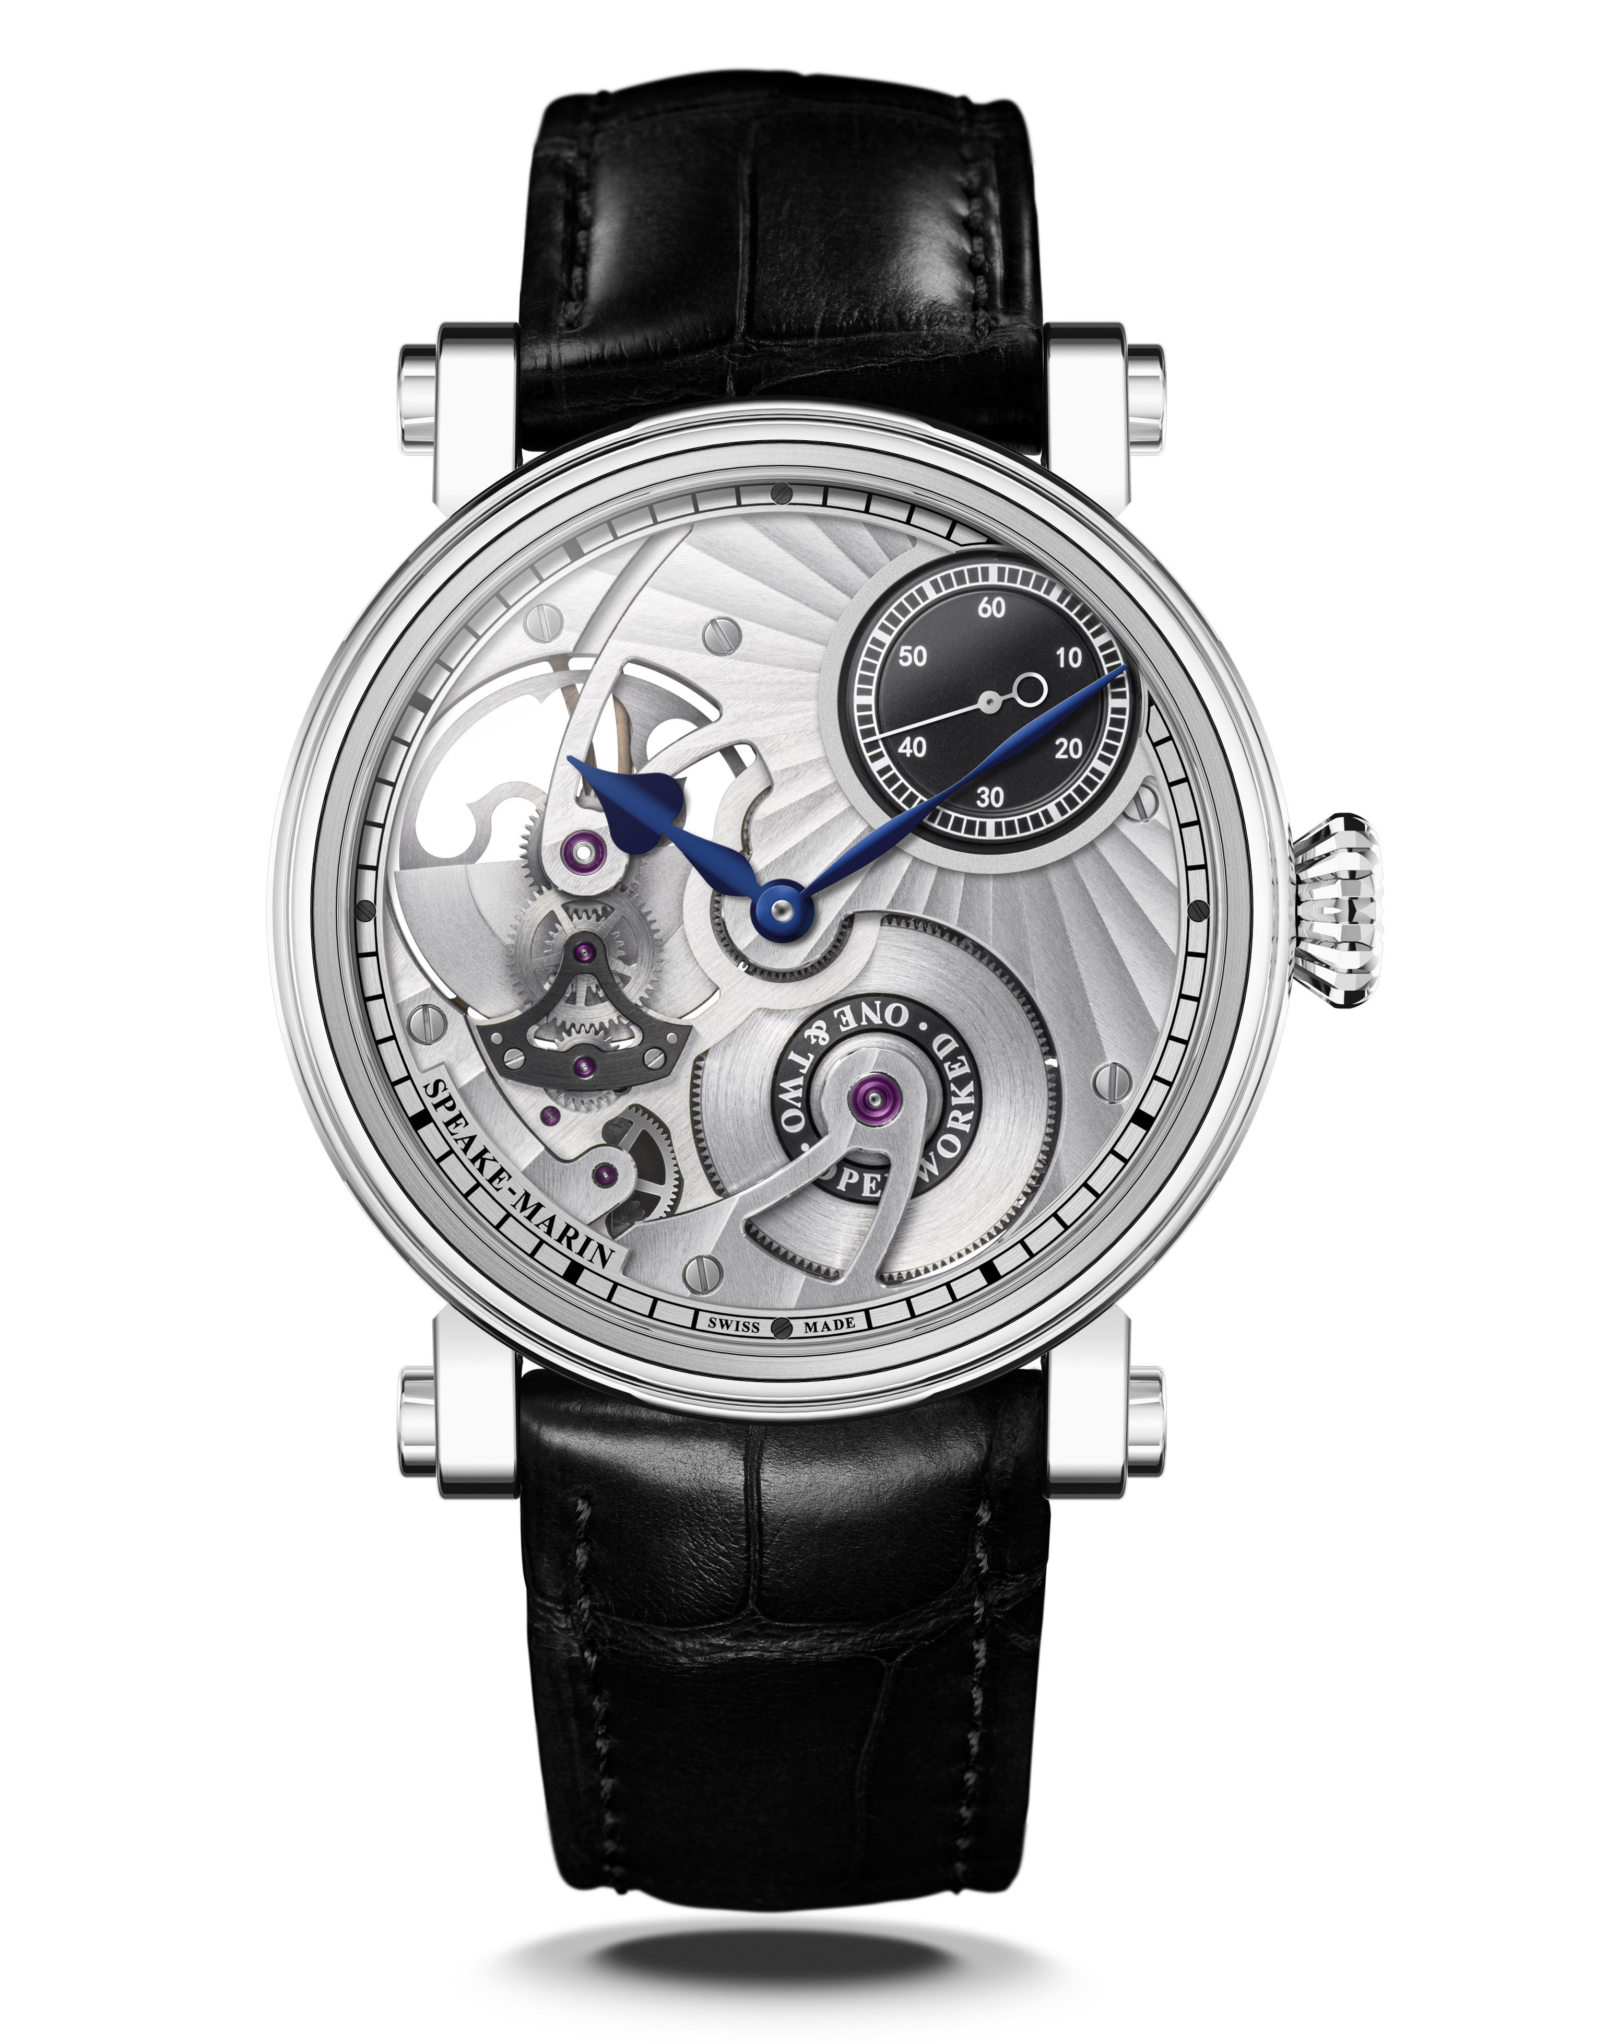

One&Two OPENWORKED HMS V3
September 2021, Geneva – Speake-Marin revisits its iconic Openworked Hours Minutes Seconds with a new version: Openworked V3. The design is inspired by modern architecture and belongs to the One& Two collection, which highlights the Speake-Marin in-house movement.

INSPIRATION

This new aesthetic follows the codes of the One& Two Openworked collection with a strong element positioned at 1:30. For the SMA01, the strong element is the small second counter. The objective is to show the movement from the inside and to give a very uncluttered look and feel.
To do so, the chosen finish on the bottom plate is brushed (direction 1:30) versus a circular graining finish in the past editions. The sun burst Geneva stripes finish has been kept to highlight the small second counter which is the vanishing point of the dial.
The intention of the One& Two Openworked collection is to play with light and shadow. The different surface decorations and treatments on the components create a wide variation of light reflections and depth perspectives.

For this new version, the black colour has been introduced on the triangular bridge and the second counter to bring modernity. The Speake-Marin creation studio takes indeed inspiration from modern design and architecture, especially black architecture for its latest creations that you can find everywhere in megacities like London. The black colour evokes power, elegance and sophistication.

Both contemporary with the dial and classic with the case, it will please watch aficionados who want to affirm their style and individuality with an audacious watch choice that will differentiate them from others.

MOVEMENT

The movement featured in the One&Two Openworked Hours Minutes Seconds is the SMA01 Calibre: an Openworked movement, which integrates a micro-rotor. It has been designed, developed and assembled in our Haute Horlogerie workshop near Neuchatel, in Switzerland.

The SMA01 movement is inspired by the architectural «Deconstructivism movement», which challenges the regular architecture and opens new possibilities: sloping walls, sloping floors, rounded rooftops, etc… (cf. Franck Gehry, Daniel Liebeskind, Zaha Hadid among others)

In this case, Speake-Marin challenges the position of the small second and imagines it at 1:30. It generates a new movement design with rounded bridges, openings in the plate, new positions of the wheels and a vanishing point at 1:30. The movement has a visual balance between the barrel, the oscillating mass and the small seconds at 1:30. It creates a triangle shape, which plays with the number “three”. This design is the foundation for the whole Speake-Marin Openworked movement collection.

The SMA01 calibre has been optimized for this new SMA01 generation and includes now a reverse wheel allowing a self-winding on both rotations.

PICCADILLY CASE

The new generation of the Piccadilly case is more technical than the original one allowing the straps to be integrated closer in the case, moving the crown further into the case so as to soften its aesthetics whilst maintaining its original DNA.

The bezel and the case back slightly overlap the central case section altering the overall “look” of the watch while maintaining the iconoclastic feel of Speake-Marin. In addition, the glass traditionally set into the bezel has now been altered to a box form, reducing the overall thickness of the case and accentuating the technical aspect of the watch.

_________________________________________________________________________________
SPEAKE-MARIN “IN-HOUSE” MOVEMENTS STRATEGY

Since 2015, Speake-Marin has initiated a movement strategy to fully develop and assemble proprietary movements within its atelier in the Neuchatel area, Switzerland. This new strategy gave birth to the “SMA” collection, which includes Openworked, closed dials and Haute Horlogerie movements. Firstly, Speake-Marin focused its efforts on Haute Horlogerie 3 Hz movements (Minute Repeater and Double Tourbillon). Then, Speake-Marin developed Hour Minutes Seconds 4Hz movements, which were featured in the new One&Two design as an Openworked movement named SMA01.
This movement is particular due to the small seconds counter being positioned at 1:30 and its integrated micro-rotor. The new SMA01 Calibre is part of the SMA movement family and follows the Openworked collection approach with the small seconds at 1:30. The small seconds at 1:30 meets the Speake-Marin objective to break-away from the watchmaking codes: Speake-Marin is the only watchmaker who positions the small seconds there. It is actually a real constraint in terms of movement development since the small seconds at 1:30 have to go through the time setting module.

Follow us:

One&Two OPENWORKED V3

MOVEMENT SMA01 Calibre, self-winding movement with integrated micro-rotor

INDICATIONS Hours Minutes and Seconds. Small seconds at 1:30

DIAL Openworked dial. Sun burst Geneva stripes finish
Heart-shaped blued steel hands.

POWER RESERVE 52 hours

CASE New generation Piccadilly case in titanium
Front and back sapphire crystal treated with anti-reflective coating.

DIAMETER 38 or 42 mm

WATER RESISTANCE 3 bar (30 metres)

STRAP & BUCKLE Black alligator, folding buckle in titanium

LIMITED EDITION 38mm: 19 pieces | 42mm: 19 pieces

REFERENCE 38mm: 413813330 | 42mm: 414213330

PRICES 38mm: 17,825 CHF without tax | 42mm: 18,400 CHF without tax
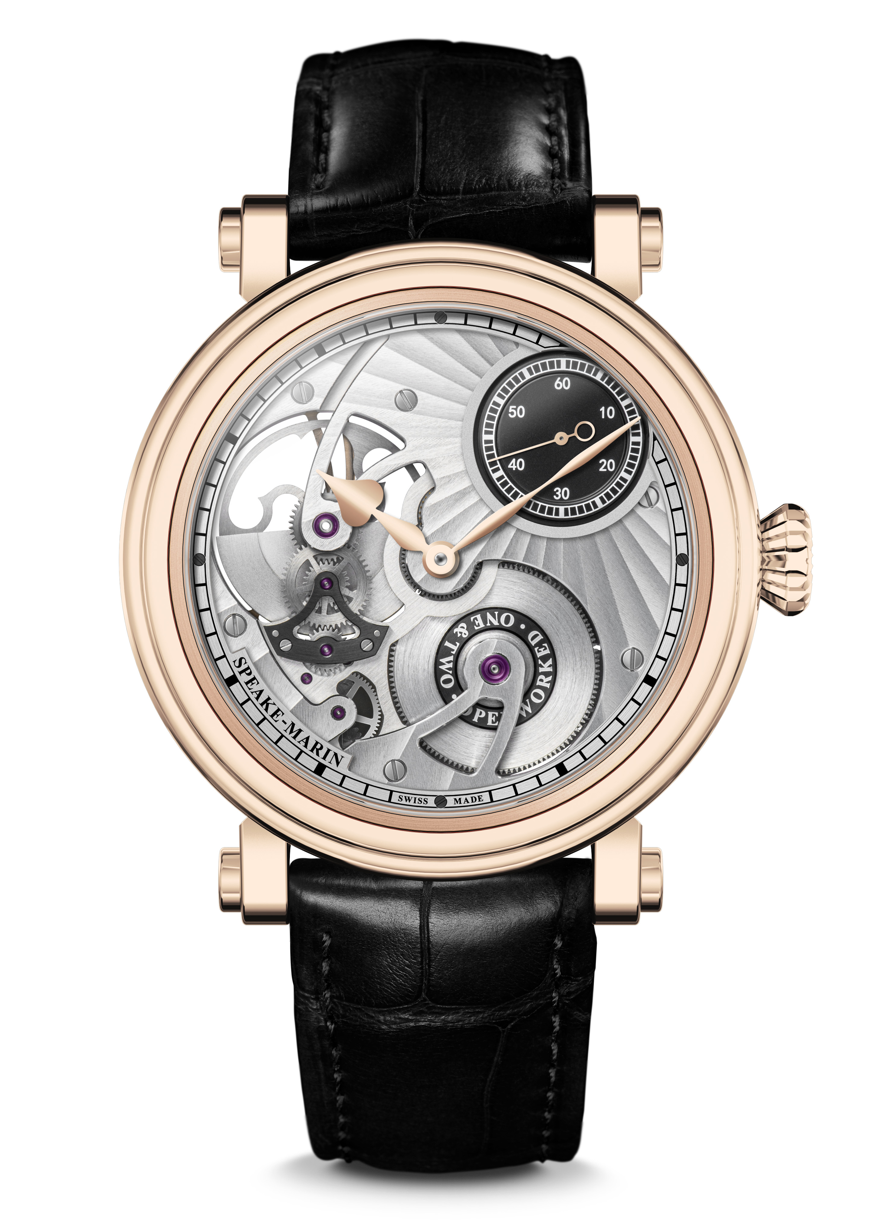
One&Two OPENWORKED V3

MOVEMENT SMA01 Calibre, self-winding movement with integrated micro-rotor

INDICATIONS Hours Minutes and Seconds. Small seconds at 1:30

DIAL Openworked dial. Sun burst Geneva stripes finish
Heart-shaped golden hands

POWER RESERVE 52 hours

CASE New generation Piccadilly case in red gold 5N
Front and back sapphire crystal treated with anti-reflective coating

DIAMETER 38 or 42 mm

WATER RESISTANCE 3 bar (30 metres)

STRAP & BUCKLE Black alligator, pin buckle in red gold 5N

LIMITED EDITION 38mm: 10 pieces | 42mm: 10 pieces

REFERENCE 38mm: 423813330 | 42mm: 424213330

PRICES 38mm: 31,625 CHF without tax | 42mm: 33,925 CHF without tax

