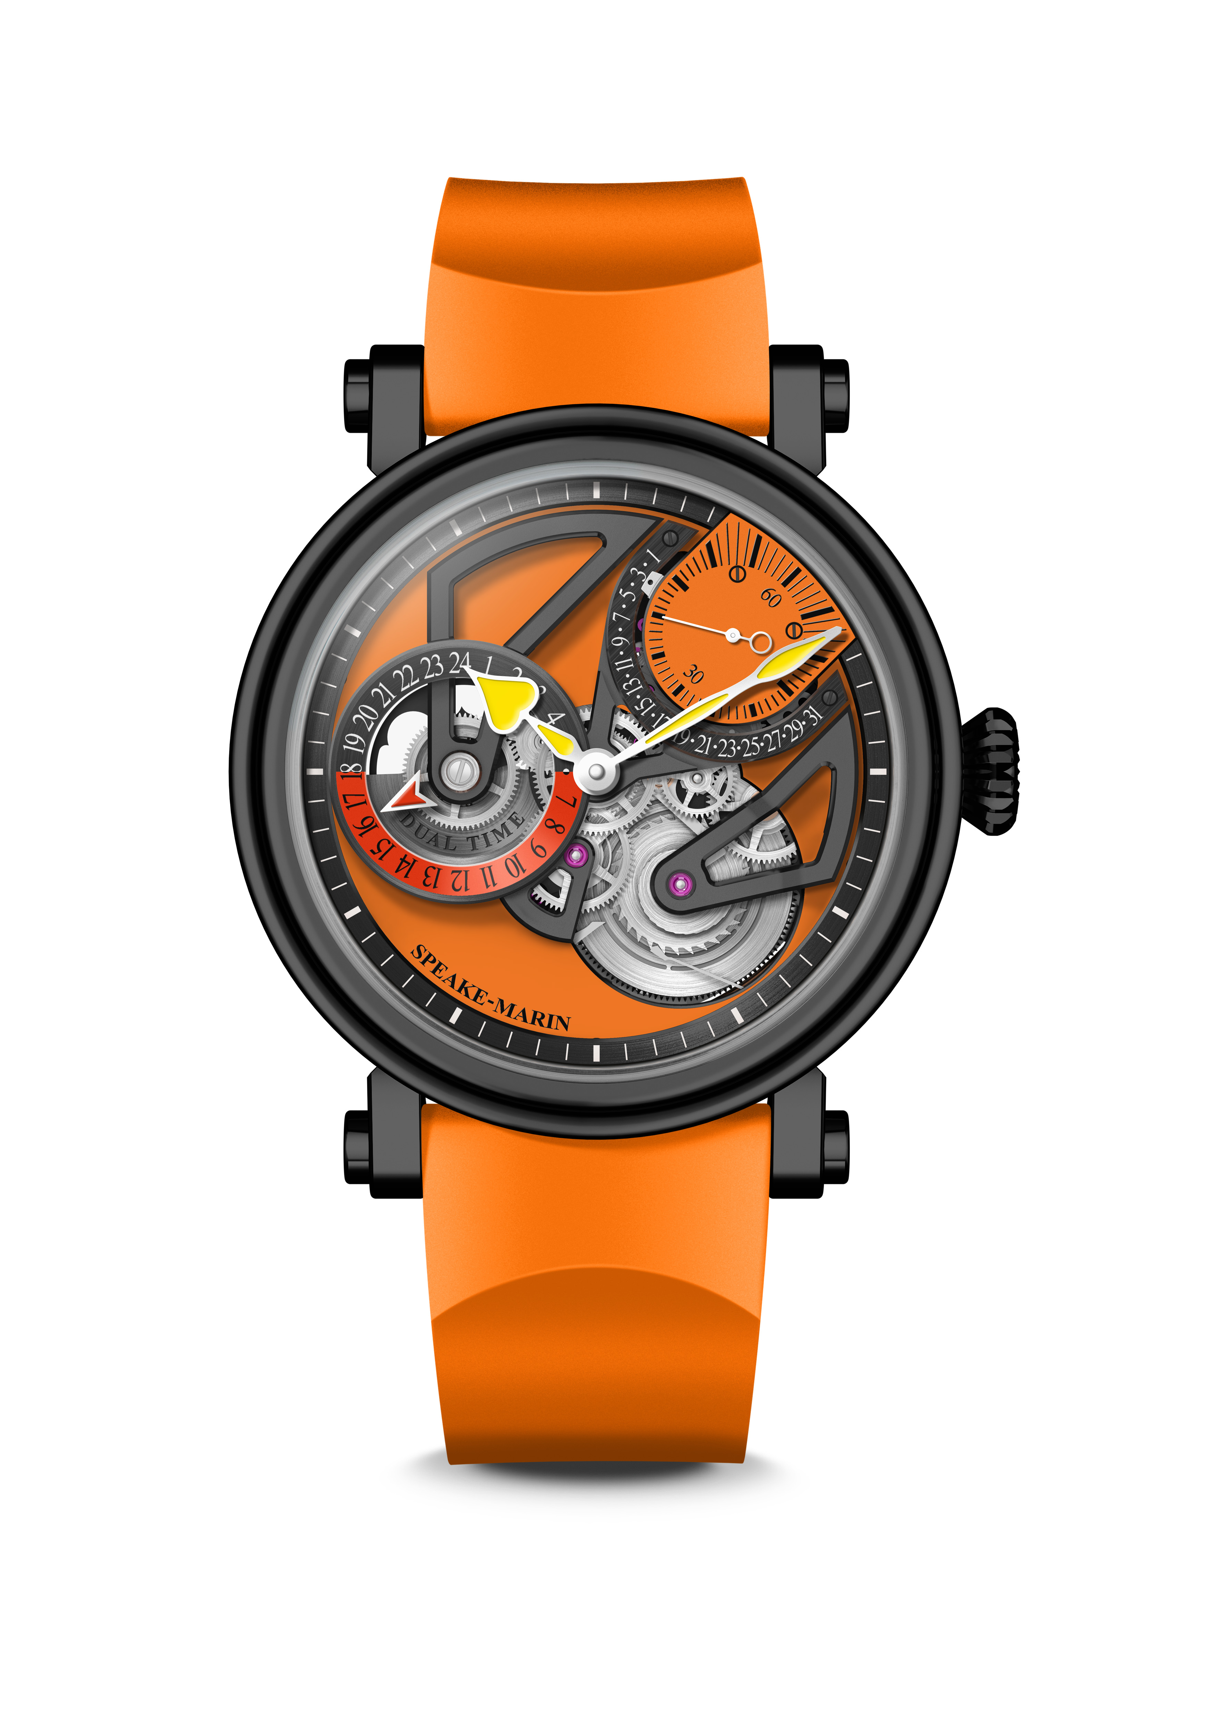
One&Two Dual Time ONLY WATCH THE SUN

July 2021 – Speake-Marin announces its participation in the ONLY WATCH auction, which will take place in Geneva in November 2021. For the third time, the independent fine watchmaking house has developed a specific timepiece and will contribute thanks to this charity sale to the research on the Duchenne Muscular Dystrophy (DMD) disease.

INSPIRATION

This new design is very powerful thanks to its colour mix and its architectural sharp angles of the dial bridges. The design plays with different tones of orange and yellow, picking up the Only Watch 2021 Edition’s pantones.
Both hyper contemporary with the dial and classic with the case, it will please travellers who want to express their style and individuality with an audacious watch choice that will differentiate them from others.
Orange has been chosen as a symbol of energy and power, referring to the Sun colour and its heating energy, which is in the centre of the solar system. Orange symbolizes as well life and hope to fight the DMD disease thanks to the very encouraging results of the research against it. Last but not least, the Sun is for ages the reference for the chronometry measure and the time split.
Speake-Marin took inspiration from the Black Architecture as well (which you can find everywhere in megacities like London) playing with black and grey applications on the case and the bridges.
For this new design, Speake-Marin proposes a dual time complication for travellers, who want to know at first glance their “Home” time versus the “Local” time. This new model is therefore the Speake-Marin travel watch par excellence, targeting travellers and digital nomads, who are looking for the perfect travel watch. This watch completes their travel attire, such as passport, noise-cancelling headphones, computer or notebook… Orange rubber strap is very easy and comfortable to wear, scratch and humidity resistant, ideal for travel.

MOVEMENT

The movement featured in the One&Two Openworked Dual Time is the SMA02 Calibre: an openworked movement, which integrates a dual time indication and a retrograde date. Inspired by modern architecture, it keeps the visual balance between the barrel, the oscillating mass and the small seconds at 1:30. It also creates a triangulation which plays with the “3” figure, as in the other Openworked models.
The Dual Time complication has been the “de facto” travel watch ever since it was conceived in the mid-50’s for Pan America pilots crossing several time zones at once. By allowing the wearer to monitor two separate time zones at once (“Local” time and “Home” time), the Dual Time watch frees its wearer from the “gruelling” mental maths required when keeping tabs on whatever is going on in your home time zone. Here, the “Local” time is given by the central Hours Minutes Seconds indication, while the “Home” time can be easily seen on the second dial at 9 o’clock.

BLACK CASE

This movement is nestled in a black DLC-coated titanium version of the new Piccadilly case, an evolution of the iconic original case of Speake-Marin. DLC stands for diamond-like carbon coating, which turns regular steel black and certainly creates a nice unique look. The coating consists of carbon particles and is chemically applied to the object. The layer is extremely durable and scratch-resistant.The case is also engraved on the side in yellow with: “ONLY WATCH 2021”.
This latest case is more technical advanced than the original, allowing the straps to be integrated closer into the case, moving the crown further into the case as well to soften its aesthetics whilst maintaining its original DNA. The bezel and the case back slightly overlap the central case section altering the overall “look” of the watch while maintaining the iconoclastic feel of Speake-Marin. In addition, the glass traditionally set into the bezel has now been altered to a box form, reducing the overall thickness of the case and accentuating the technical aspect of the watch.

___________________________________________________________________________

SPEAKE-MARIN “IN-HOUSE” MOVEMENTS STRATEGY
Since 2015, Speake-Marin has initiated a movement strategy to fully develop and assemble proprietary movements within its workshop in the Neuchatel area, Switzerland. This new strategy gave birth to the “SMA” collection, which includes Openworked, closed dials and Haute Horlogerie movements. Firstly, Speake-Marin focused its efforts on Haute Horlogerie 3 Hz movements (Minute Repeater and Double Tourbillon). Then, Speake-Marin developed Hour Minutes Seconds 4Hz movements, which were featured in the new One&Two design as an Openworked movement named SMA01. This movement is particular due to the small seconds counter being positioned at 1:30 and its integrated micro-rotor. The new SMA02 Calibre is part of the SMA movement family and follows the Openworked collection approach with the small seconds at 1:30. The small seconds at 1:30 meets the Speake-Marin objective to break-away from the watchmaking codes: Speake-Marin is the only watchmaker who positions the small seconds there. It is actually a real constraint in terms of movement development since the small seconds at 1:30 have to go through the time setting module.
One&Two Dual Time ONLY WATCH THE SUN

MOVEMENT SMA02 Calibre, self-winding movement with micro-rotor
Retrograde date and Dual Time indication

INDICATIONS Hours Minutes and Seconds. Small seconds and retrograde date at 1:30
Dual Time indication at 9 o’clock

DIAL Openworked dial. Black mat finish
Dual Time indication in black and dark orange
Heart-shaped yellow lacquered hands

POWER RESERVE 52 hours

CASE New generation Piccadilly case in black DLC-coated titanium
Front and back sapphire crystal treated with anti-reflective coating

DIAMETER 42 mm

WATER RESISTANCE 3 bar (30 metres)

STRAP & BUCKLE Orange rubber, pin buckle in black DLC-coated steel

REFERENCE 414214370

UNIQUE PIECE

