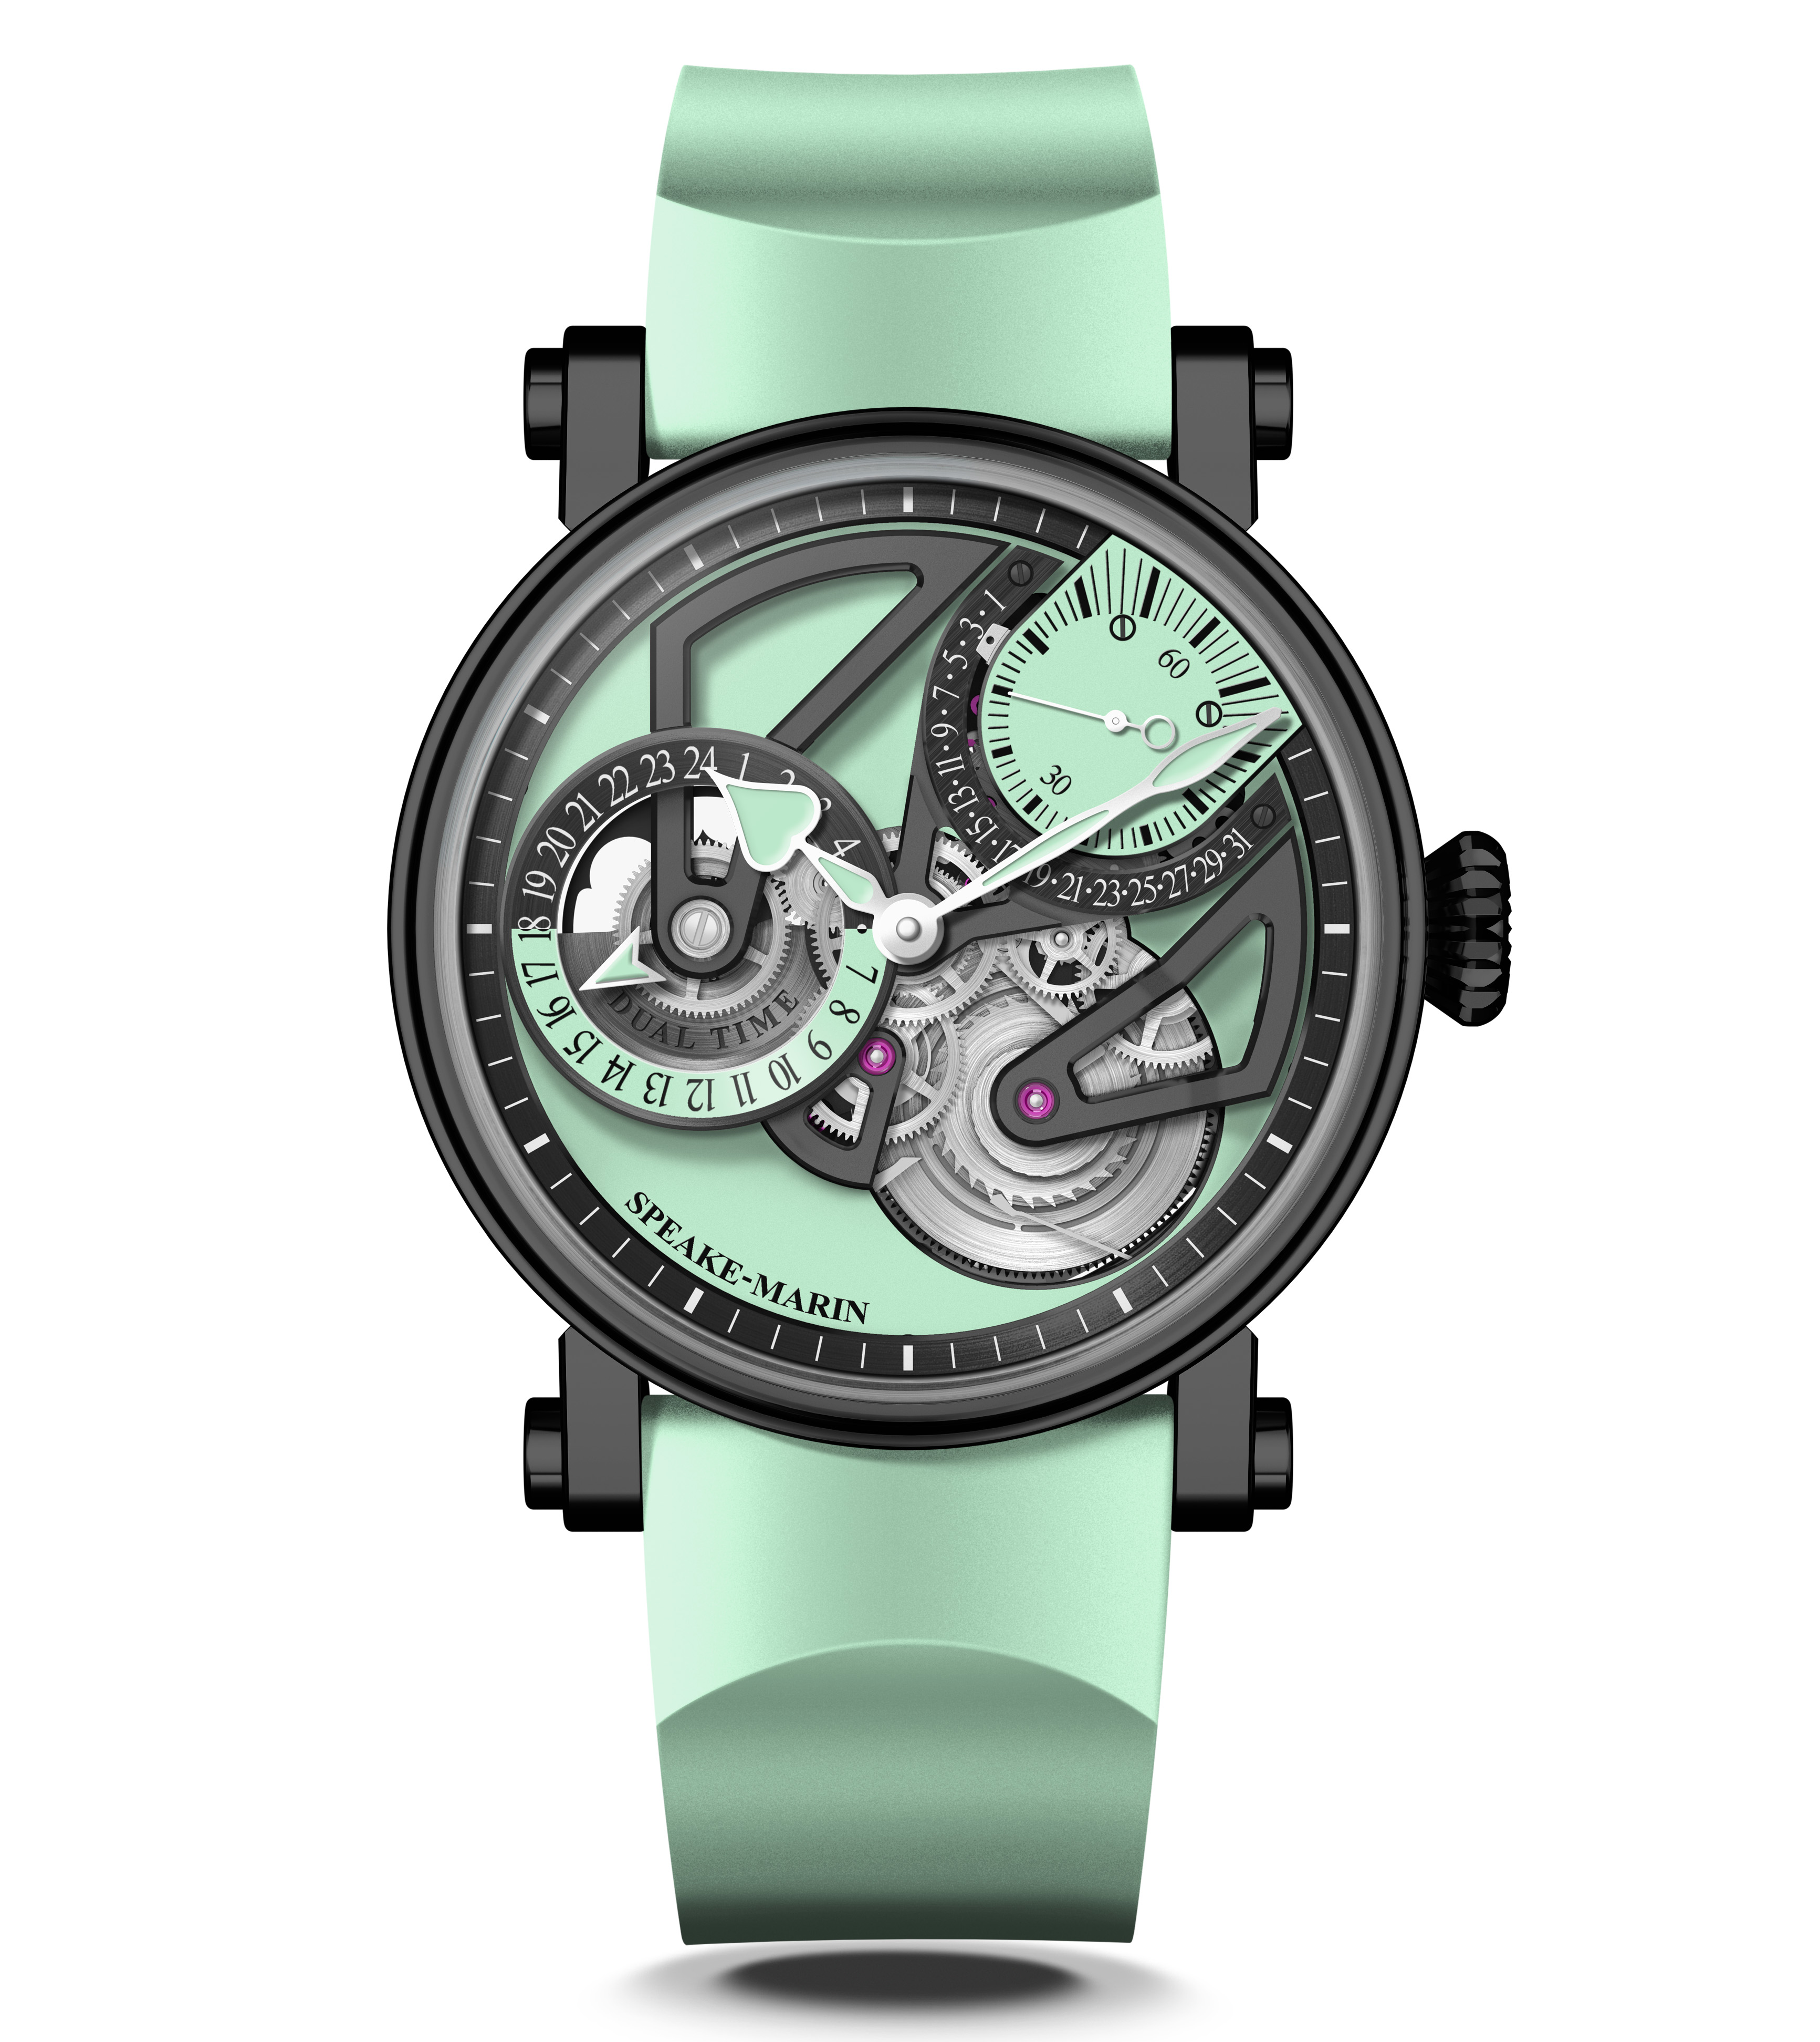

One&Two OPENWORKED Dual Time MINT

Watches&Wonders Geneva 2021 –Speake-Marin enriches its Openworked collection with a new timepiece: Dual Time MINT with retrograde date, a design inspired by the Black Architecture movement and it proposes an audacious colour “Mint “as a hymn to freedom.

INSPIRATION

This new aesthetic is very modern thanks to its colour mix (mint green, silver and black) and its sharp angles of the bridges. Both hyper contemporary with the dial and classic with the case, it will please travellers who want to affirm their style and individuality with an audacious watch choice that will differentiate them from others.
Mint has been chosen as a hymn to freedom, an aspiration for travel and new spaces referring to the colour of Caribbean/Indian Ocean/South Sea. Speake-Marin took inspiration from the Black Architecture movement too (that you can find everywhere in megacities like London) playing with black and grey applications on the case and the bridges.

For this new design, Speake-Marin proposes indeed a complication for travellers, who want to know at first glance their “Home” time versus the “Local” time. This new model is therefore the Speake-Marin travel watch par excellence, which targets travellers and digital nomads who are looking for the perfect travel watch, which completes their travel attire, such as passport, noise-cancelling headphones, computer or notebook…

MOVEMENT

The movement featured in the One&Two Openworked Dual Time is the SMA02 Calibre: an Openworked movement, which integrates a Dual Time indication and a retrograde date. Inspired by architecture, it keeps the visual balance between the barrel, the oscillating mass and the small seconds at 1:30. It creates a triangulation which plays with the “3” figure, as in the other Openworked models.

The Dual Time complication has been the “de facto” travel watch ever since it was conceived in the mid-’50s for Pan America pilots crossing several time zones at once. By allowing the wearer to monitor two separate time zones at once (“Local” time and “Home” time), the Dual Time watch frees its wearer from the “gruelling” mental maths required when keeping tabs on whatever is going on in your home time zone. Here, the “Local” time is given by the central Hours Minutes Seconds indication, while the “Home” time can be easily seen on the second dial at 9 o’clock.

BLACK CASE

This movement is nestled in a black DLC-coated titanium version of the new Piccadilly, an evolution of the iconic case of Speake-Marin. DLC stands for Diamond-like carbon (coating), which turns regular steel black and certainly creates a nice unique look. The coating consists of carbon particles and is chemically applied to the object. The layer is extremely durable and scratch-resistant.
The new case is more technical than the original allowing the straps to be integrated closer in the case, moving the crown further into the case so as to soften its aesthetics whilst maintaining its original DNA. The bezel and the case back slightly overlap the central case section altering the overall “look” of the watch while maintaining the iconoclastic feel of Speake-Marin. In addition, the glass traditionally set into the bezel has now been altered to a box form, reducing the overall thickness of the case and accentuating the technical aspect of the watch.

________________________________________________________________________________

SPEAKE-MARIN “IN-HOUSE” MOVEMENTS STRATEGY
Since 2015, Speake-Marin has initiated a movement strategy to fully develop and assemble proprietary movements within its atelier in the Neuchatel area, Switzerland. This new strategy gave birth to the “SMA” collection, which includes Openworked, closed dials and Haute Horlogerie movements. Firstly, Speake-Marin focused its efforts on Haute Horlogerie 3 Hz movements (Minute Repeater and Double Tourbillon). Then, Speake-Marin developed Hour Minutes Seconds 4Hz movements, which were featured in the new One&Two design as an Openworked movement named SMA01. This movement is particular due to the small seconds counter being positioned at 1:30 and its integrated micro-rotor. The new SMA02 Calibre is part of the SMA movement family and follows the Openworked collection approach with the small seconds at 1:30. The small seconds at 1:30 meets the Speake-Marin objective to break-away from the watchmaking codes: Speake-Marin is the only watchmaker who positions the small seconds there. It is actually a real constraint in terms of movement development since the small seconds at 1:30 have to go through the time setting module.

One&Two OPENWORKED Dual Time MINT

MOVEMENT SMA02 Calibre, self-winding movement with micro-rotor
Retrograde date and Dual Time indication

INDICATIONS Hours Minutes and Seconds. Small seconds and retrograde date at 1:30
Dual Time indication at 9 o’clock

DIAL Openworked dial. Black mat finish.
Dual Time indication in black and mint green.
Heart-shaped mint green lacquered hands.

POWER RESERVE 52 hours

CASE New generation Piccadilly case in black DLC-coated titanium
Front and back sapphire crystal treated with anti-reflective coating.

DIAMETER 38 or 42 mm

WATER RESISTANCE 3 bar (30 metres)

STRAP & BUCKLE Mint green rubber, pin buckle in black DLC-coated steel

LIMITED EDITION 38mm: 10 pieces | 42mm: 18 pieces

REFERENCE 38mm: 413809290 | 42mm: 414209290

PRICES 38mm: 29,400 CHF without tax | 42mm: 29,900 CHF without tax

