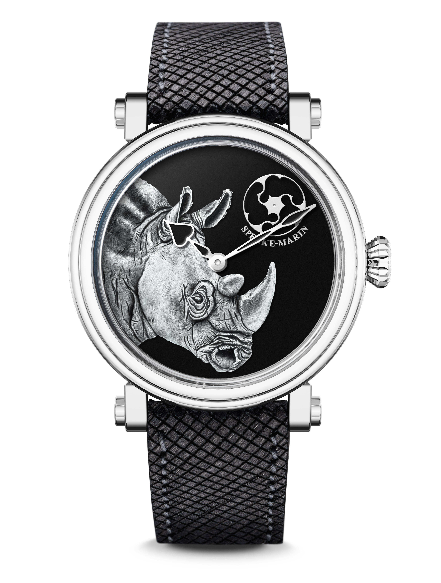
ART-SERIES Rhinoceros

October 2020 - As Speake-Marin is aware of the 21st century’s challenges from environmental and social perspectives, the watchmaking house has launched in 2020 a few initatives to impact the world in a positive way.

One of these projects is to launch every year an Art-Series limited edition dedicated to endangered species: part of the sales will be given to a chosen organisation, which acts for their protection.
For this first year, Speake-Marin develops a limited edition of 9 pieces in partnership with the London-based charity “Save the Rhino International”, an organisation working to ensure that all five species of rhinoceros thrive in the wild by protecting their habitat, reducing illegal trade, involving local communities and bringing experts together.
With this project, Speake-Marin contributes to the costs of protecting critically endangered rhinoceros at the Sumatra Rhino Sanctuary in Indonesia, thanks to a CHF 3,000 gift per each timepiece sold. Would you like to find out more ? Please visit the website: www.savetherhino.org

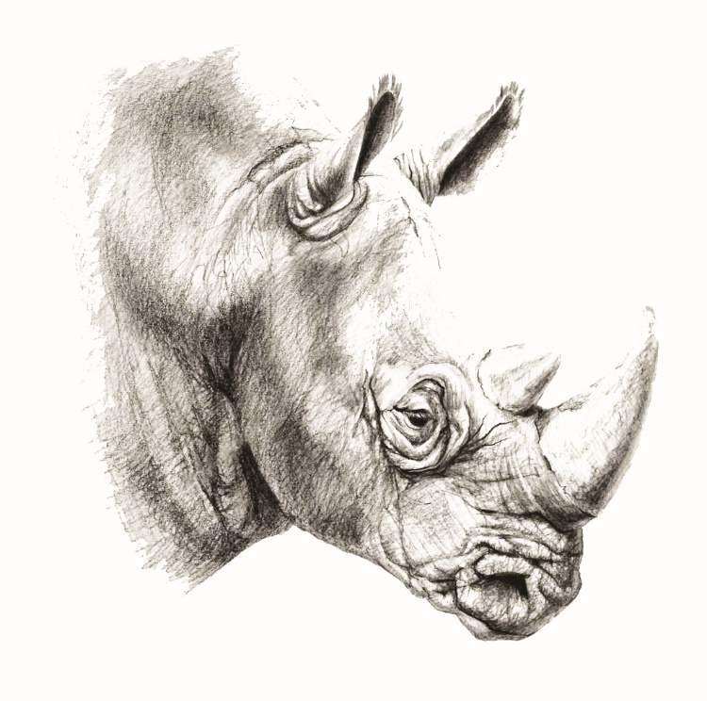

SPEAKE-MARIN & ART SERIES

In 2006, Speake-Marin started to design and develop the so called “Art-Series”, a collection of timepieces that is dedicated to craftsmanship. Speake-Marin includes in the Art-series different traditional techniques such as enamelling, hand-engraving, Maki-e (Japanese art of lacquer work).

Engraving is indeed part of Speake-Marin DNA and is corroborated within its Art-Series collection through beautiful watch dials: Skulls, Dragon or animals are magnified thanks to this technique. Speake-Marin uses both hand and chemical engraving methods, depending on the design complexity.

For this latest limited edition, the rhinoceros has been designed in our creation studio and sculpted by hand (more than 40 hours) to produce a special master stamp, which is then reproduced on each dial. The silver-plated sculpted rhinoceros is hand finished with an oxidising acid to reach this unique shade of grey.

To finish the dial, approximately 15 layers of black lacquer have been applied to reach the perfect consistency both in colour and finish.

SMA03 IN-HOUSE MOVEMENT

Since 2014, Speake-Marin has initiated a movement strategy to fully develop and assemble in-house movements within its workshop in Neuchâtel area, Switzerland. This new strategy gave birth to the “SMA” collection, which includes Openworked, closed dials and Haute Horlogerie movements. At first, Speake-Marin focused its efforts on Haute Horlogerie 3Hz movements (Minute Repeater and Double Tourbillon). Then, Speake-Marin developed Hour Minutes Seconds 4Hz movements, which were featured in the One&Two collection.

The SMA03 Calibre is part of the SMA movement family and introduces the first closed dial with small seconds at 1:30. The movement, which you can discover in the back of the watch, has the particularity to have an integrated micro-rotor.

A SPECIFIC STRAP IN WOOD
Speake-Marin wanted to propose a specific eco-friendly strap for this new limited edition. The bracelet has been created from lime tree wood (tilia europaea specie), with the interior layer in natural cork. The wood sourcing is certified 100% FSC-forests, which means that the wood comes from responsibly-managed forests that meet the highest environmental and social standards.
Why did we choose lime trees? Lime tree wood has the characteristics to be both very resistant and flexible.
For more information: www.fsc.org

Art-Series Rhinoceros

MOVEMENT SMA03, Speake-Marin in-house movement

INDICATIONS Hours and Minutes
Small second counter at 1:30

POWER RESERVE 48 hours

CASE Iconic Piccadilly case in titanium (grade 5)
Front sapphire crystal, treated with anti-reflective coating

DIAMETERS 38 mm and 42 mm

WATER RESISTANCE 3 bar (30 metres)

DIAL Rhinoceros in silver
Black glossy lacquer

HANDS Heart-shaped black-lacquered and silver hands

STRAP & BUCKLE Lime tree wood bracelet, interior in natural cork
Folding buckle in titanium

LIMITED EDITION 9 pieces

REFERENCES 38 mm: 413813360 | 42 mm: 414213360

PRICES 38 mm: CHF 28,000 excl. tax | 42 mm: CHF 28,500 excl. tax

